Practical research on the method of pulling qi through traditional Chinese medicine inward observation & examination
Jie Wu，a；Wanfeng Zhu ，b ；Jinyang Liang ，c ； Zitao Yi，d；Liu Zhengqiang， e*
Jiangxi University of Chinese Medicine, Nanchang, 330004, Jiangxi, China
e：Email： 277208964@163.com.
Abstract: The traditional Chinese medicine (TCM) inward observation & examination is a newly-developing science integrated with Qigong and is a very important part of TCM. Method of pulling qi is the basic method to perceivie the qi of the human body, which is simple and widely used in traditional Chinese medicine inward observation & examination. This paper analyzes the observation effect and sense of the method of pulling qi through practical feedback. In terms of the effect of observing, it was found that the palm qi pulling method(compared with the zhongkui(EX-UE4) qi pulling method and the fingertip qi pulling method)has the highest effective rate and significant rate in both observing one's own qi of human body and helping others observe qi of human body.In terms of observing experience, hotness is the most obvious, followed by flowing sensation and squeezing sensation. At the same time, the most frequently mentioned words in overall perception are concentration and peace.The method of pulling qi can help practitioners to observe the qi of the human body efficiently, which is an effective method in traditional Chinese medicine inward observation & examination, and is worth popularizing.
Key words:Traditional Chinese medicine inward observation & examination;Qi of human body;Method of pulling qi;Qi sense
Funding:Jiangxi University of Traditional Chinese Medicine Provincial Key Student Innovation and Entrepreneurship Training Program（202410412054S）,Jiangxi University of Traditional Chinese Medicine Provincial Undergraduate Innovation and Entrepreneurship Training Program(S202410412132X)，Jiangxi University of Traditional Chinese Medicine School-level Student Innovation and Entrepreneurship Training Program（202410412140X），Jiangxi University of Traditional Chinese Medicine School-level Student Innovation and Entrepreneurship Training Program（202410412316）
Introduction
TCM inward observation & examination is a technique based on the life view of TCM and the methods of Qigong inward observation, aiming to comprehend and perceive the internal state and changes of human life, recognize, strengthen, and renew one's own life process, and further comprehend and transform the relationship between humans and nature, ultimately achieving the goal of comprehending TCM theory and promoting clinical development in TCM. The perception of qi in the human body is the core content of TCM inward observation & examination, with various methods such as Yi Xiang Fa (thought-based method), Chen Qi Fa (stretching qi method), La Qi Fa (pulling qi method), Peng Qi Guan Ding Fa (holding qi and connecting the crown method), San Xin Bing Zhan Zhuang (standing with three minds combined method), Xing Shen Zhuang (Form and Spirit Method), and Wu Yuan Zhuang (Five Elements Method). Among these, the method of pulling qi serves as the foundational approach for perceiving qi in the human body [1]. According to previous research, beginners practicing this method can quickly perceive qi sensations between their hands [2]. This paper further delves into the observational effects of the method of pulling qi.
The Qi-Pulling Method, created by Professor Pang Heming, a specially-appointed professor at Jiangxi University of Traditional Chinese Medicine, is an important technique for perceiving the Qi in the human body. The Qi-Pulling Method emphasizes strengthening both internal and external Qi, integrating them into one. It allows for quick acquisition of Qi and a strong sensation of Qi, making it an introductory practice for perceiving Qi. Instructions for the practice: 1. Place your hands in front of your chest or abdomen, palms facing each other in a ball-holding position. Then, use your elbows to guide your upper limbs in a smooth, even motion of opening and closing, while perceiving the sensation of Qi between your hands. 2. When your hands are in front of your body, visualize them as being connected, as if holding a balloon that is attached to your body. As you open your arms, imagine the balloon expanding outward from your body, with many threads of Qi stretching and connecting between your hands. When you bring your hands in, focus on the balloon shrinking and the Qi seeping into your body.
1. Analysis of the Method of Pulling Qi to Perceive Qi in the Human Body
According to the basic theory of TCM, there are four kinds of movement modes of ascending, descending, exiting and entering in the qi of human body. As stated inPlain Questions: The Subtle Pivot of Sixfold Manifestations (Suwen·Liuwei Zhi Da Lun) , "All things have ascending, descending, exiting, and entering movements" [3]. The "ascending" and "exiting" of qi are embodied in "opening," while the "descending" and "entering" are embodied in "closing." Therefore, opening and closing are the most fundamental movement patterns of qi in the universe. The method of pulling qi utilizes this principle, guiding the opening and closing of qi in the human body through the opening and closing of both hands in coordination with the opening and closing of the mind. This allows for the perception of qi between both hands and further mobilizes qi throughout the body, connecting the qi inside and outside the body, promoting the exchange of internal and external qi, and ensuring sufficient and smooth qi within the body, thereby perceiving qi throughout the body.
To improve the efficiency of using the method of pulling qi to perceive qi between both hands, three forms of pulling qi were specifically created: palm qi pulling method, zhongkui qi pulling method, and fingertip qi pulling method. Through different hand gestures and mental activities, combined with specific acupuncture points, these methods help enhance qi sensation experiences for beginner practitioners. Firstly, the palm qi pulling method involves placing both hands in front of the chest or abdomen with palms facing each other and fingers slightly curved, forming a ball-holding posture. Subsequently, both upper limbs are moved by the elbows, opening and closing uniformly, and perceiving the qi sensation between and around both hands. When in front of the body, the mind connects both hands as if holding a balloon that is connected to the body; when opening, the balloon expands as if qi threads are connecting the hands; when closing, attention is paid to the balloon shrinking and penetrating into the body. Secondly, the zhongkui(EX-UE4) qi pulling method involves placing both hands in front of the chest or abdomen with palms facing each other, thumbs slightly bent, and the other four fingers curved, with the middle phalangeal backsides facing each other, aligning the zhongkui(EX-UE4) acupoints of both hands. Subsequently, both upper limbs are moved by the elbows, opening and closing uniformly, and perceiving the qi sensation between and around both hands. Thirdly, the fingertip qi pulling method involves using the sword finger gesture, where the ring finger and little finger are bent, the thumb is pressed against the knuckles of these two fingers, and the index and middle fingers are straight and together. One hand is placed in front of the chest or abdomen with the palm facing inward, while the other hand adopts the sword finger gesture, aiming the sword finger at the Laogong(PC8) acupuncture point on the palm. Subsequently, both upper limbs are moved by the elbows, opening and closing uniformly, or the sword finger circles clockwise or counterclockwise around the palm, perceiving the qi sensation between and around both hands.
2. Practical Research on the Method of Pulling Qi to Perceive Qi in the Human Body
A training session on the method of pulling qi (palm qi pulling method, zhongkui(EX-UE4) qi pulling method, and fingertip qi pulling method) was conducted among 48 beginner college students of TCM inward observation & examination at Jiangxi University of Traditional Chinese Medicine to perceive qi in the human body. The training involved perceiving qi between one's own hands through the method of pulling qi and assisting others in perceiving qi between their hands. Feedback from the training session was collected to analyze the effects of the method of pulling qi on perceiving qi in the human body and the data on qi sensation.
2.1 Analysis of the Effects of the Method of Pulling Qi on Perceiving Qi in the Human Body
The effects of the method of pulling qi on perceiving qi in the human body are presented in Table 1 and Figure 1 and 2 below:
Table 1: Comparison of the Effectiveness of Qi-Pulling Methods in Perceiving Human Qi
Form | Qi-Pulling Method | Effective Participants | Strong Qi Sensation | Weak Qi Sensation | No Qi Sensation | Effectiveness Rate | Significance Rate
Self-Perception of Qi | Palm Qi-Pulling Method | 45 | 36 | 7 | 2 | 95.56% | 80.00%
Self-Perception of Qi | Zhongkui Qi-Pulling Method | 32 | 13 | 13 | 6 | 81.25% | 40.63%
Self-Perception of Qi | Fingertip Qi-Pulling Method | 31 | 23 | 5 | 3 | 90.32% | 74.19%
Assisting Others in Qi Perception | Palm Qi-Pulling Method (Self) | 49 | 38 | 9 | 2 | 95.92% | 77.55%
Assisting Others in Qi Perception | Palm Qi-Pulling Method (Other) | 49 | 34 | 11 | 4 | 91.84% | 69.39%
Assisting Others in Qi Perception | Fingertip Qi-Pulling Method (Self) | 40 | 30 | 8 | 2 | 95.00% | 75.00%
Assisting Others in Qi Perception | Fingertip Qi-Pulling Method (Other) | 40 | 27 | 9 | 4 | 90.00% | 67.50%
Note:
Effectiveness Rate (%) = (Number with Strong Qi Sensation + Number with Weak Qi Sensation) / Total Effective Participants × 100%
Significance Rate (%) = Number with Strong Qi Sensation / Total Effective Participants × 100%
Figure 1: Bar Chart of the Effectiveness of Qi-Pulling Methods in Self-Observing One's Own Body's Qi 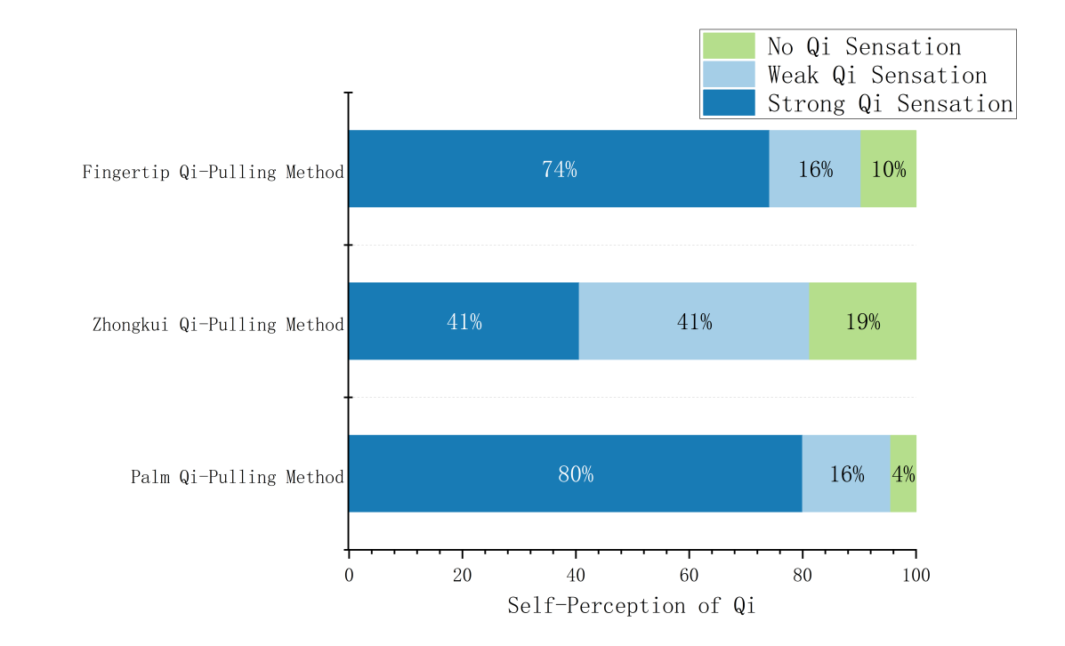
Figure 2: Bar Chart of the Effectiveness of Qi-Pulling Methods in Assisting Others to Perceive Their Body's Qi
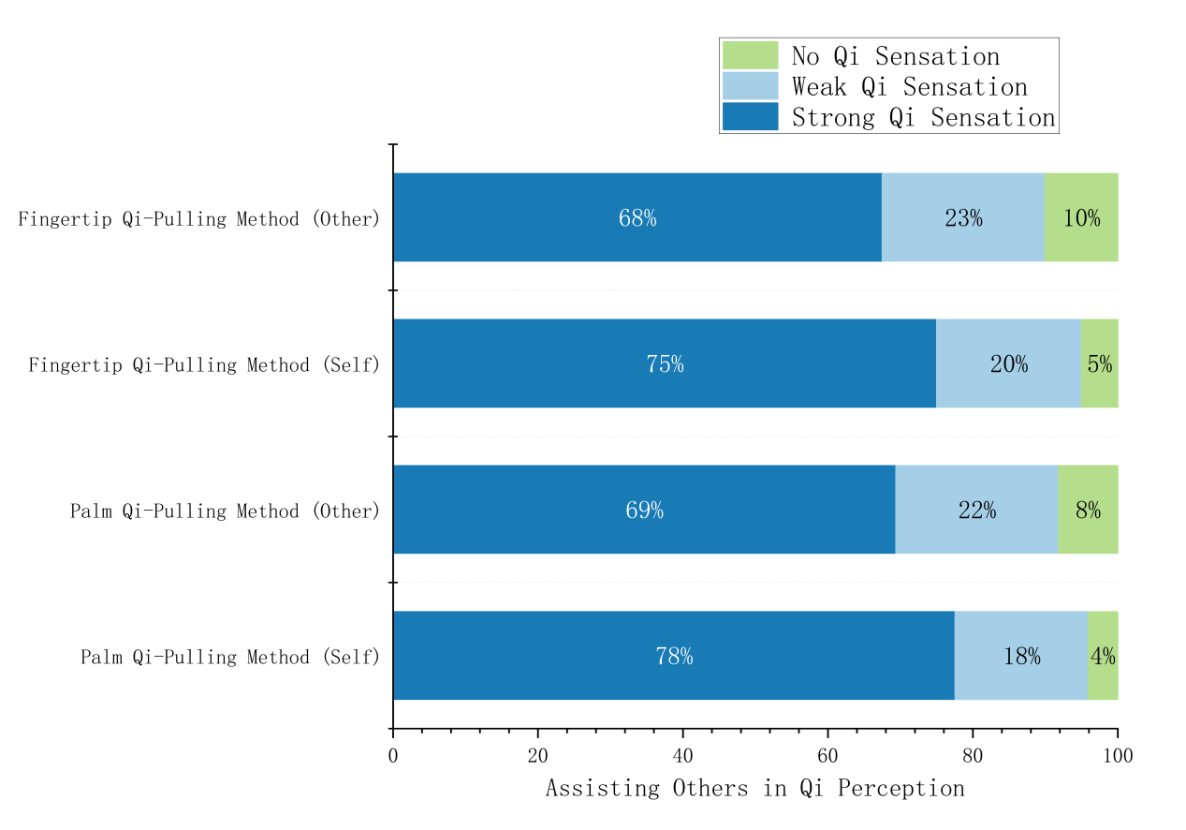
As shown in Table 1 and Figure 1 and 2, among the three methods of pulling qi for perceiving qi in the human body, both the effective rate and significant rate are above 80% for perceiving one's own qi and assisting others in perceiving qi, indicating good observational effects. This suggests that the method of pulling qi can help students quickly perceive the actual existence of qi in the human body, establish a concept of qi, and enhance their confidence in learning TCM.
Among the three methods of pulling qi, the palm qi pulling method exhibits the highest effective rate and significant rate for both perceiving one's own qi and assisting others in perceiving qi. The zhongkui(EX-UE4) qi pulling method has the lowest effective rate and significant rate for perceiving one's own qi, and no participants chose this method when assisting others in perceiving qi. The reasons for this are analyzed as follows:
Firstly, the Laogong(PC8) acupoint plays a crucial role in the palm qi pulling method. The palm qi pulling method adopts a hand posture with palms facing each other and hands forming a ball-holding shape. The Laogong(PC8) acupoint, as the Ying (ying spring) acupoint of the Hand Jueyin Pericardium Meridian, is located at the center of the palm between the second and third metacarpal bones and occupies an important position in TCM theory. As recorded in Lingshu: The Nine Needles and Twelve Source Points (《灵枢·九针十二原》)states, "The human body's Five Zang-organs (五脏) each possess five specific Shu-points (腧穴), yielding twenty-five Shu-points through fivefold calculation (五五二十五腧). The Six Fu-organs (六腑) each contain six designated Shu-points, totaling thirty-six through sixfold computation (六六三十六腧). With twelve regular meridians (经脉) and fifteen collateral meridians (络脉), these channel systems manifest twenty-seven distinct patterns of channel Qi (经气) circulating throughout the body.The sites where channel Qi emanates from the extremities are termed Jing-well (井, well-spring) points; where Qi begins its subtle flow become Ying-spring (荥, spring) points; where Qi converges and infuses are designated Shu-stream (输, stream) points; where Qi flows vigorously are named Jing-river (经, river) points; and where Qi deepens and converges are called He-sea (合, sea) points. All twenty-seven patterns of channel Qi circulation fundamentally correlate with the Five Shu-point system." Ying acupoints represent places where pulse qi gradually becomes vigorous, making the Laogong(PC8) acupoint a crucial node for regulating qi and blood in the pericardium meridian. Based on TCM meridian theory, the Laogong(PC8) acupoint has unique physiological and therapeutic effects, closely related to heart function. Its main functions include clearing the heart and calming the spirit, extinguishing wind and cooling the blood, and awakening the spirit and opening orifices. It is used to treat symptoms such as heart fire hyperactivity, restless heart, anxiety, insomnia, and digestive system disorders like stomach fire hyperactivity and halitosis. In "The Great Compendium of Acupuncture and Moxibustion (Zhenjiu Dacheng)" the application of the Laogong acupoint involves heart, spleen, stomach, liver, and gallbladder system diseases, as well as qi, blood, body fluids, limbs, meridians, and facial diseases. From an anatomical perspective, the Laogong acupoint is surrounded by the palmar venous network, the palmar proper digital artery, and the palmar branch of the median nerve, with rich vascular and neural distributions making the perception in the Laogong acupoint region more sensitive. In Qigong, the Laogong acupoint is known as the "Human Gate," serving as an essential channel for the exchange of internal and external qi. By focusing on the Laogong acupoint, practitioners can achieve the release of internal qi and the absorption of external qi, promoting the interaction between human qi and natural qi. Previous studies, such as Zeng Yating et al.'s [4] infrared thermography detection before and after Qigong exercise among 38 college students, demonstrated that Qigong exercise can increase the infrared temperature of the Laogong(PC8) acupoints on both hands, while no significant change was observed in the Shaofu(HT8) acupoints, proving the uniqueness of the Laogong(PC8) acupoint in Qigong exercise. This shows that the Laogong(PC8) acupoint plays a key role in Qigong cultivation. Zhang Zhounan et al. [5] used terahertz spectroscopy to detect the right-hand Laogong(PC8), Shaofu(HT8) acupoints, and non-acupoint areas of 50 college students, finding significant differences in terahertz radiation between acupoints and non-acupoint areas, indicating the specificity of acupoints to terahertz waves. Liu Jiancheng et al. [6] also utilized terahertz spectroscopy to detect six different meridian acupoints[Laogong(PC8), Yuji(LU10), Shaofu(HT8), Hegu(LI4), Houxi(SI2), Zhongzhu(TE3)] before and after TCM inward observation among 37 healthy college students. The results showed that TCM inward observation increased the qi capacity of the Laogong acupoint the most, inferring that compared to the other five acupoints on the hand, the Laogong(PC8) acupoint has more surrounding nerves, blood vessels, tendons, and other tissues that disseminate qi with their respective attributes. In particular, the lateral muscle group of the thenar eminence and the medial muscle group of the hypothenar eminence surround the Laogong(PC8) acupoint in the middle depression of the hand, causing their qi to concentrate and coincide at the Laogong(PC8) acupoint, enhancing its qi capacity.
Secondly, among the three methods of pulling qi, the posture of the palm qi pulling method is the most relaxed. As the palm is an important tactile area of the human body, it is frequently used in daily activities such as grasping, sensing temperature, and manipulating objects, which continuously exercises and applies the tactile perception of the palm, making it rich in tactile feedback and further deepening people's perception and understanding of the palm. In contrast, the posture of the zhongkui qi pulling method requires bending the four fingers and aligning the middle phalangeal backsides, making the hands relatively tense, which is不利于the smooth circulation of qi and blood in the hands. Additionally, the zhongkui acupoint is unfamiliar to most beginner practitioners.
In summary, during practice, whether pulling qi for oneself or assisting others, the palm qi pulling method can be preferred as it provides a better qi sensation experience, stimulating a deeper interest in TCM inward observation & examination.
2.2 Analysis of Sensory Experiences of the Method of Pulling Qi on Perceiving Qi in the Human Body
The qi sensation data of the method of pulling qi are presented in Table 2 and Figures 3, 4, 5, and 6 below, with overall sensory experiences shown in Table 2 and Figures 7 and 8.
Table 2: Qi Sensation Description Table for Qi-Pulling Methods
Form | Qi-Pulling Methods | Qi Sensation (Number of People) | Overall Feeling (Number of People)
Qi-Pulling Methods for Perceiving One's Own Body Qi | Palm-centered Qi-drawing Method | Warmth (25), Flowing Sensation (18), Tingling Sensation (3), Radiating Sensation (2), Attraction Sensation (9), Repulsion Sensation (15), Balloon-like Sensation (11), Dough-like Sensation (3), Water Balloon-like Sensation (3), Silk-pulling Sensation (6), Full and Enveloping Sensation (2), Swelling Sensation (5), Shrinking Sensation (3), Squeezing Sensation (5) | Calm (10), Focused (9), Natural (3), Alert (2), Joyful (2), Clear and Unblocked (7), Relaxed and Comfortable (5)
Qi-Pulling Methods for Perceiving One's Own Body Qi | Middle Finger Knuckle Qi-drawing Method | Warmth (9), Flowing Sensation (6), Qi Thread Pulling Sensation (10), Tingling Sensation (2), Swelling Sensation (1), Gathering and Dispersing Sensation (1), Resistance Sensation (1), Squeezing Force (2), Expanding and Contracting Force (2), Pulling Force (1) | Relaxed (3), Calm (3), Focused (3), Alert (1), Natural (1)
Qi-Pulling Methods for Perceiving One's Own Body Qi | Fingertip Qi-drawing Method | Warmth (18), Qi Flowing Sensation (8), Qi Rushing Sensation (2), Qi Mass Enveloping Sensation (3), Rotating Sensation (9), Silk-pulling Sensation (3), Tingling Sensation (3), Squeezing Sensation (3), Gathering and Enveloping Sensation (2), Tense and Relaxed Sensation (1), Attraction Sensation (2), Repulsion Sensation (3) | Focused (2), Calm (1)
Qi-Pulling Methods to Assist Others in Perceiving Human Qi | Palm-centered Qi-drawing Method (Self) | Blocking Sensation (13), Warmth (29), Flowing Sensation (18), Qi Rushing Sensation (1), Silk-pulling Sensation (2), Tingling Sensation (6), Swelling Sensation (2), Alternating Cool and Warm Sensation (3), Attraction Sensation (5), Repulsion Sensation (8), Circulating and Transmitting Sensation (2), Diverging Sensation (2), Gathering and Enveloping Sensation (3), Dough-like Sensation (3), Balloon-like Sensation (4), Swelling Sensation(2), Retracting Sensation (2), Gathering and Dispersing Sensation (1) | Relaxed and Comfortable (5), Calm (3), Alert (1), Smooth and Natural (1), Sense of Wholeness (4), Clear (1), Joyful (1), Sense of Fusion (4)
Qi-Pulling Methods to Assist Others in Perceiving Human Qi | Palm-centered Qi-Pulling Method (Others) | Squeezing Sensation (7), Warmth (27), Flowing Sensation (18), Pulling and Tugging Sensation (5), Qi Thread Silk-pulling Sensation (2), Swelling Sensation (2), Penetrating Sensation (1), Electric Current Sensation (3), Tingling Sensation (5), Gathering Sensation (2), Dough-like Sensation (2), Full and Enveloping Sensation (2) | Relaxed and Comfortable (3), Serene (1)
Qi-Pulling Methods to Assist Others in Perceiving Human Qi | Fingertip Qi-Pullin Method (Self) | Stirring Sensation (8), Rotating Sensation (7), Warmth (19), Flowing Sensation (10), Penetrating Sensation (4), Pulling Sensation (3), Squeezing Sensation (1), Resistance Sensation (3), Tingling Sensation (1), Enveloping Sensation (1), Alternating Cool and Warm Sensation (1), Qi Thread Sensation (1), Qi Beam Sensation (1), Dough-like Sensation (1) | Transmitting and Connecting (3), Focused (1)
Qi-Pulling Methods to Assist Others in Perceiving Human Qi | Fingertip Qi-Pullin Method (Others) | Stirring Sensation (6), Rotating Sensation (10), Warmth (15), Flowing Sensation (9), Penetrating Sensation (2), Pulling Sensation (2), Squeezing Sensation (3), Gathering Sensation (1), Contracting Sensation (2), Expanding Sensation (2), Swelling Sensation (1), Uneven Sensation (1), Alternating Cool and Warm Sensation (4), Pulsating Sensation (2), Ant-crawling Sensation (3), Electric Current Sensation (2), Qi Beam Sensation (1) | Transmitting (3), Sense of Fusion (1)

Figure 3:Bar chart of Qi sensation in self-observing the body’s Qi through Pulling Qi method
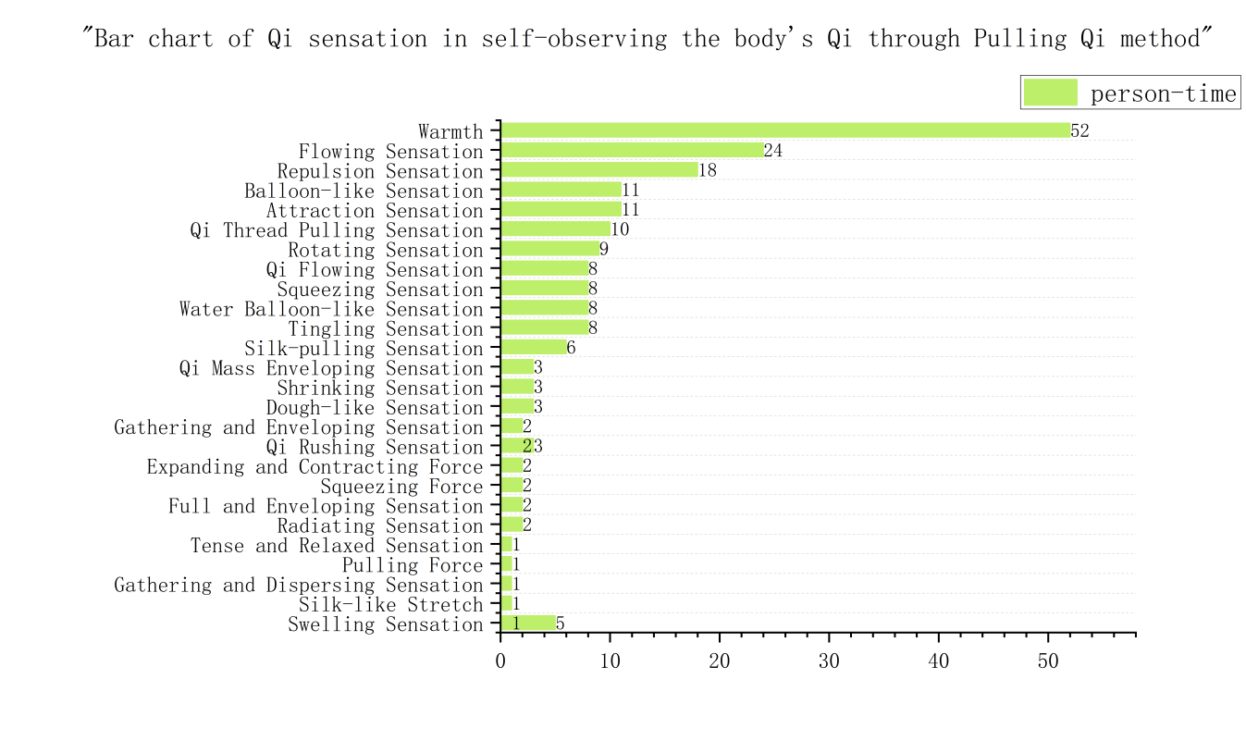
Figure 4:Bar chart of Qi sensation in assisting others to preceive their body’s Qi through Pulling Qi method
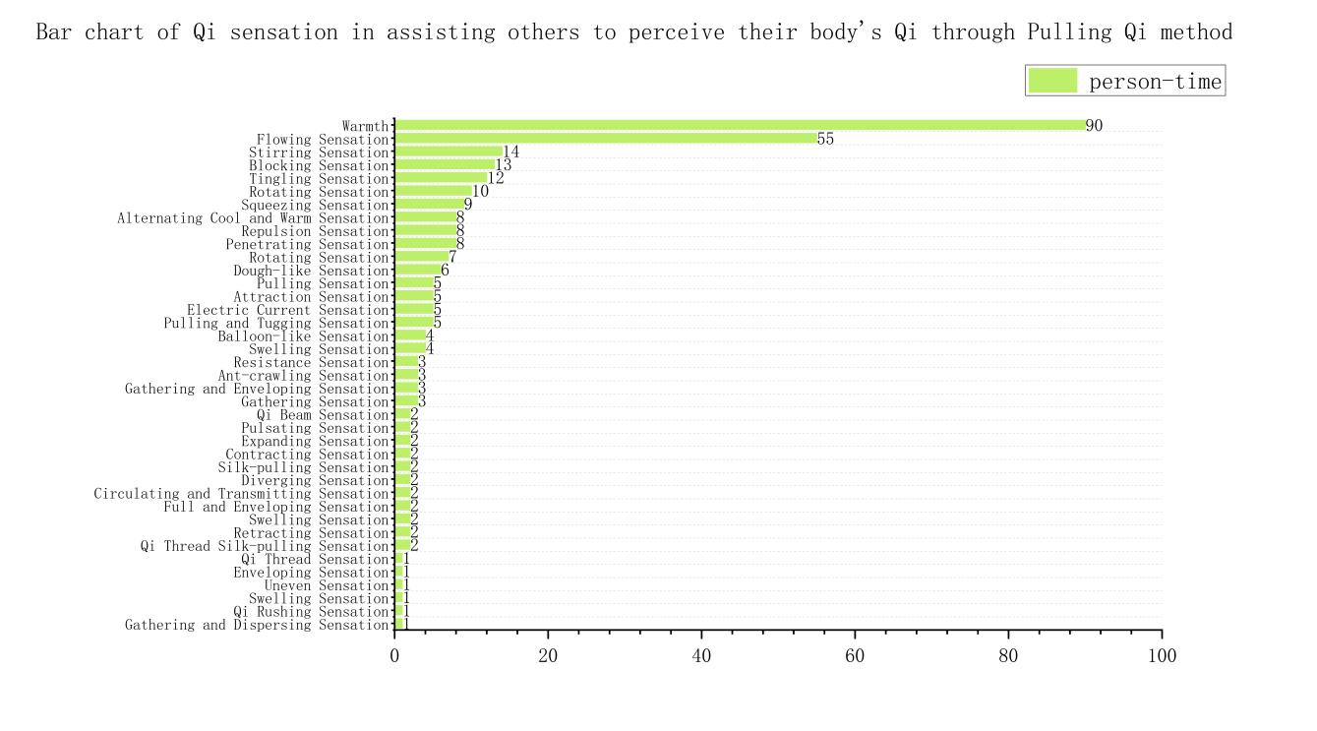
Figure 5:Pie chart of the number of people who self-observed their body's Qi and experienced Qi sensations through Qi-Pulling Methods
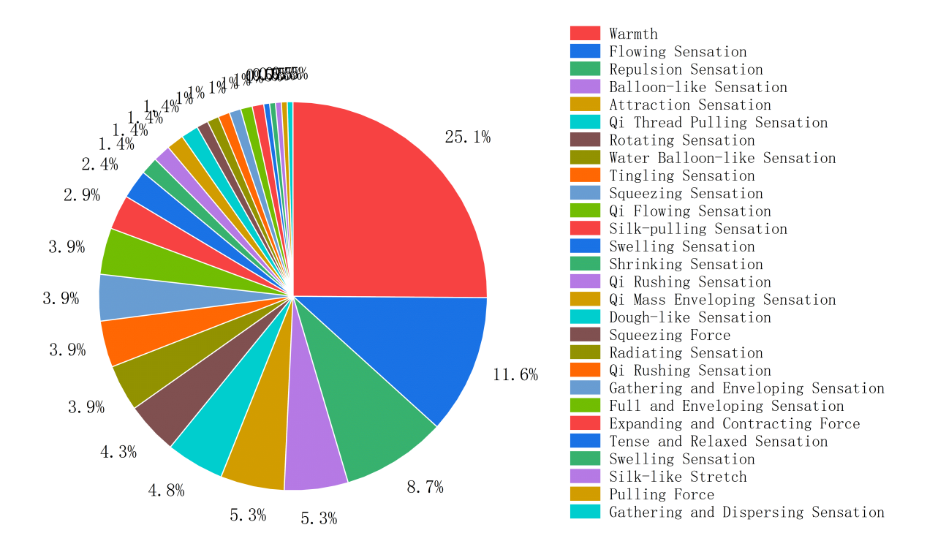
Figure 6:Pie chart of the number of people who assisted others in perceiving their body's Qi and experienced Qi sensations through Qi-Pulling Methods
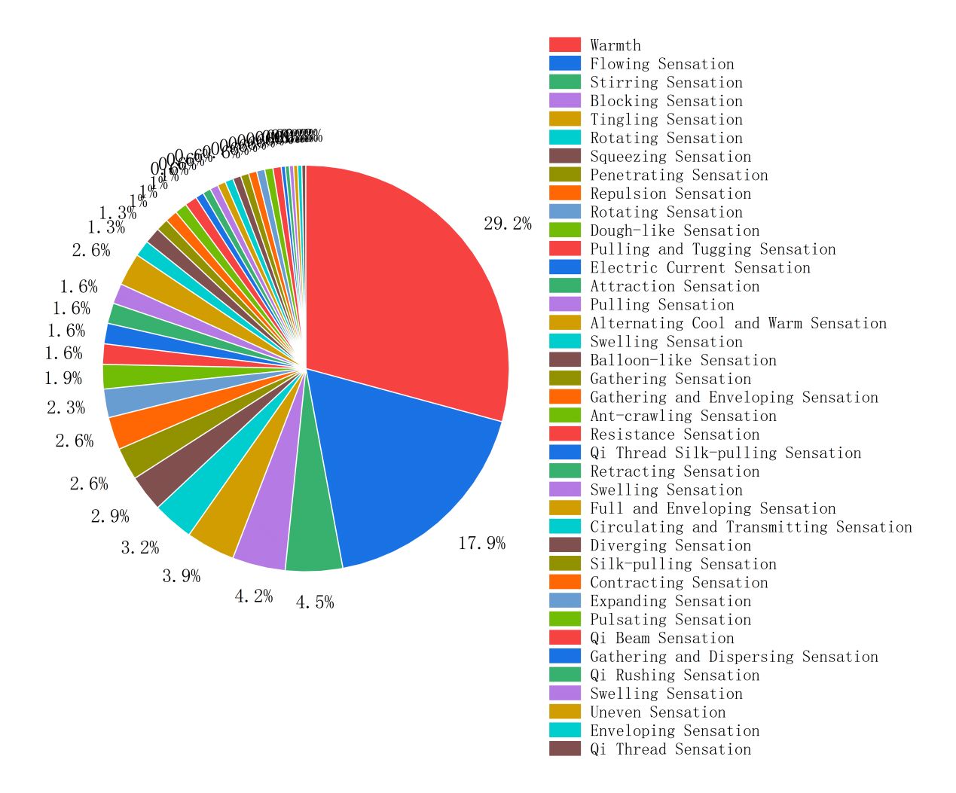
Figure 7:Bar chart of overall Qi sensation in self-observing the body’s Qi through Pulling Qi method
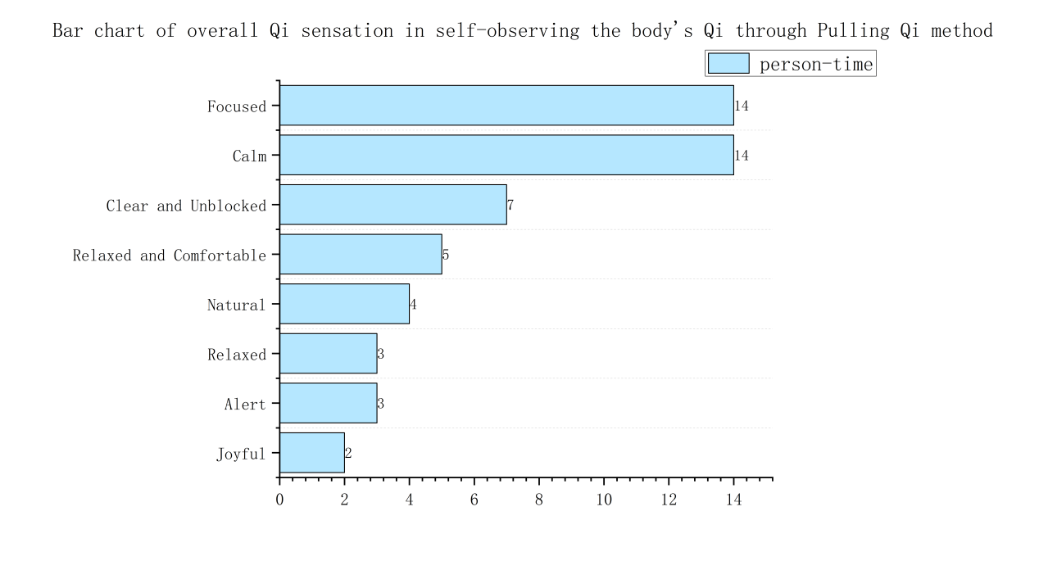
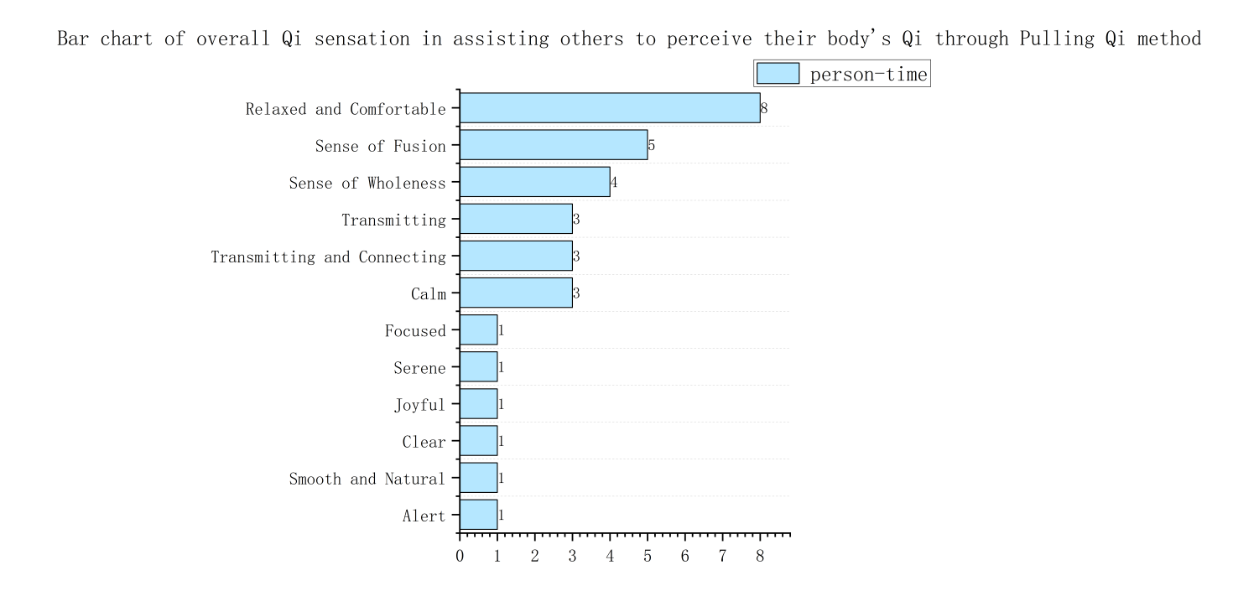
Figure 8:Bar chart of overall Qi sensation in self-observing the body’s Qi through Pulling Qi method
2.2.1 Analysis of Qi Sensation Experience
Based on Figures 3, 4, 5, and 6, it is intuitively apparent that whether using the Qi-pulling method to perceive one's own Qi or to assist others in perceiving their Qi, the sensation of heat is the most prominent, followed by the sensations of flow and pressure (including similar sensations of repulsion, resistance, etc.). Let's analyze the reasons below.
I.Analysis of Why the Sensation of Heat is Most Prominent:
Firstly, it can be explained by the traditional Chinese medicine (TCM) principle that "excessive Qi turns into fire." In Qigong, through specific physical movements and mental activities, Qi circulates within the body and gathers in a certain area. When Qi accumulates to a certain extent locally, it may generate a sensation of heat. Qigong can also stimulate meridians and acupoints, promote the circulation of Qi and blood, unblock meridians, and allow Qi and blood to flow smoothly throughout the body, resulting in a general feeling of warmth. This phenomenon reflects the theory of "Qi gathering turns into fire," meaning that the local accumulation and intensification of Qi can be transformed into fire with warming properties. The heat sensation generated by Qi-pulling can be seen as a process of Qi gathering and transforming into fire, which is a concrete manifestation of the TCM concept that "excessive Qi turns into fire."
Secondly, Qigong practitioners can induce specific bodily reactions, including the sensation of heat, through focused intention. For example, The Classic of Health Preservation and Dermatological Care states:"For deficiency patterns (虚病), one should practice mental concentration and introspective practices (存想收敛) to consolidate the spirit and strengthen the inner fortification (固密心志，内守之功).For excess patterns (实病), apply therapeutic massage with daoyin exercises (按摩导引), combined with controlled breathing and acupressure techniques (吸努掐摄), to disperse pathogenic accumulation.For heat patterns (热病), employ respiratory purification (吐故纳新) by exhaling through the mouth and inhaling through the nose to cool the body.For cold patterns (冷病), retain qi through breath retention (存气闭息) and ignite inner warmth via meditative focus (用意生火).These four methods represent a direct path to healing, surpassing the reliance on herbal or mineral-based remedies (草木金石之药)." IThe Essential Secrets of Qigong Mastery prescribes: "When Yang qi is vigorous, utilize its warm nature through mental intention to guide it toward cold pathogenic regions for dispelling cold pathogens; when Yin qi is abundant, employ its cool characteristics through mental concentration to direct it toward heat-affected areas for balancing pathogenic heat.""In winter, visualize oneself in a warm indoor environment through mental intention to mobilize Yang qi, thereby inducing bodily warmth; in summer, even at home, employ mental concentration to activate Yin qi, creating a cooling sensation. This embodies the TCM health preservation principles of conforming to nature and regulating qi movement to achieve physical-mental harmony."
Thirdly, the interaction between human tissue structure and human Qi is similar to the phenomenon of friction generating heat. When Qi and structure change, coupled with body temperature, it is easy to produce a sensation of heat. Based on the basic principle of friction generating heat, when two object surfaces come into contact and move relative to each other, friction occurs on the contact surface. This process converts mechanical energy into thermal energy, resulting in a temperature increase. In TCM, "Qi" not only permeates and fills the human body's tissues and organs but also diffuses around the body. Therefore, during the Qi-pulling process, the interaction between the human tissue structure (the two hands) and the Qi in and between the hands can also produce a friction-like effect, generating heat.
II. Analysis of Why Sensations of Flow and Pressure are More Frequent:
Sensation of Flow. The sensation of flow experienced during Qigong practice is closely related to the theory of the essence of meridians. Based on the Qi theory and the trinity of body-Qi-spirit life view, Zhang Wenchun et al. [7] proposed the fascia gap Qi channel theory to explain the essence of meridians, suggesting that a Qi beam forms in the gaps between the fascial connective tissue systems, which is the meridian. Meridians are channels for the circulation of Qi and blood in the human body and are closely related to the nervous system, vascular system, lymphatic system, etc. Qigong practice can promote the flow of Qi and blood in the body, generating a sensation of flow, and can also regulate the nervous system, vascular system, and lymphatic system to produce a sensation of flow.
Sensations of Pressure, Repulsion, etc. Fields are objective manifestations of matter, and the forces between matter are essentially contact collisions between fields. According to current research, terahertz waves are a type of electromagnetic wave with frequencies between microwaves and infrared light, ranging roughly from 0.1 THz to 10 THz. Ren Jiankun et al. [8] demonstrated that external Qi in Qigong is an objective existence in the form of terahertz wave energy and information, and terahertz waves are an aspect of the substantial manifestation of "Qi." This indicates the presence of invisible field-like substances around the human body, including around the hands. When the two hands open and close to pull Qi and the palms approach each other, due to the distribution of the fields around the hands, contact collisions occur between the fields, enhancing the field strength in this area. This is subjectively perceived as sensations of pressure, repulsion, etc.
2.2.2 Overall Experience Analysis
As shown in Table 2 and Figures 7 and 8, the most frequent words in the overall experience of using the Qi-pulling method to perceive one's own Qi are focus and calmness. The Qi-pulling method emphasizes the use of intention, requiring practitioners to highly concentrate their spirit to perceive the changes in Qi within the body. The Dialogues of Tingxin Studio elucidates : "When the mind attains the state of transcendent serenity and mental clarity, completely merging with the natural spontaneity and non-interference, transcending dualistic attachments to “movement” and “stillness” through such advanced cultivation, the trinity of Essence (Jing), Qi, and Spirit (Shen) will naturally circulate. The meridian pathways within the body spontaneously become unobstructed, as vital energy transforms from Essence (Jing) into Qi, sublimates from Qi to Spirit (Shen), and ultimately returns the Spirit (Shen) to the primordial Void (Wuji), thereby integrating with the Dao in perfect unity." Practitioners need to focus their intention between their two hands, as if holding a balloon. This mental activity not only helps enhance the perception of Qi but also helps practitioners maintain inner calmness. When the conscious activity is quiet and calm, the body's life activities naturally undergo orderly self-regulatory changes. The most frequent words in the overall experience of using the Qi-pulling method to assist others in perceiving their Qi are relaxation and comfort. "The ascending, descending, entering, and exiting movements of Qi (气的上升、下降、进入、排出) constitute fundamental motion patterns that universally manifest in all living organisms without exception." In the process of internally perceiving life, by regulating the body, Qi, and spirit, the human body achieves an optimized state of the trinity of body-Qi-spirit.
3. Conclusion
The Qi-pulling method can help TCM students intuitively feel the existence and changes of "Qi," thereby deepening their understanding of the concept of "Qi." In TCM theory, "Qi" is the basic substance that constitutes the human body and maintains life activities, and it is the driving force of life activities. As a basic method for perceiving Qi, the Qi-pulling method can help practitioners understand the movement and changes of Qi through their own experiences, thereby enhancing their ability to internally perceive. On the one hand, the practice of the Qi-pulling method helps verify and enrich the basic theories of TCM, especially those related to Qi. Through direct perception of Qi, one can explore the laws of Qi's generation, circulation, and transformation, providing more empirical support for TCM theory. On the other hand, the practice and research of the Qi-pulling method provide possibilities for modern science to explore human Qi, helping to reveal the modern scientific essence of Qi as a non-physical substance. Through modern scientific research on the Qi-pulling method, the connection between Qi and fields in modern physics can be explored, providing new research perspectives and methods for modern science. Furthermore, the practice of the Qi-pulling method may reveal non-physical substances not yet discovered by modern science, opening up new fields for scientific development.
References:
[1]Zhang Wenchun. Internal Perception and Insight in Traditional Chinese Medicine [M]. Beijing: People's Medical Publishing House, 2019:3.
[2] Liu Zhengqiang, Zhang Wenchun. Inheritance and Innovation of Methods for Perceiving Human Qi through Internal Perception and Insight in Traditional Chinese Medicine [J]. Chinese Journal of Traditional Medicine, 2022, 37(01):20-23.
[3] Zheng Hongxin, Yang Zhu. Fundamentals of Traditional Chinese Medicine [M]. Beijing: China Traditional Medicine Publishing House, 2021:90.
[4] Zeng Yating, Zou Xuefang, Qiu Lieze, et al. Study on the Changes in Infrared Thermography of the Laogong Acupoint During Qigong Practice [J]. Jiangxi Journal of Traditional Chinese Medicine, 2018, 49(06):31+38.
[5] Zhang Zhounan, Qiu Lieze, Fan Zhiwen, et al. Terahertz Spectral Characteristics of the Laogong and Shaofu Acupoints and Non-Acupoint Areas on the Palm [J]. Chinese Journal of Traditional Medicine, 2019, 34(03):1178-1180.
[6] Liu Jiancheng, Qiu Lieze, Liu Zhengqiang, et al. Effects of Internal Perception and Insight on the Terahertz Wave Radiation Spectrum of Different Acupoints on the Hand [J]. Chinese Journal of Traditional Medicine, 2019, 34(02):602-604.
[7] Zhang Wenchun, Wu Xuanhui, Liu Zhengqiang. Analysis of the Essence

